Lab 12 Using DFT for linear convolution of long sequence

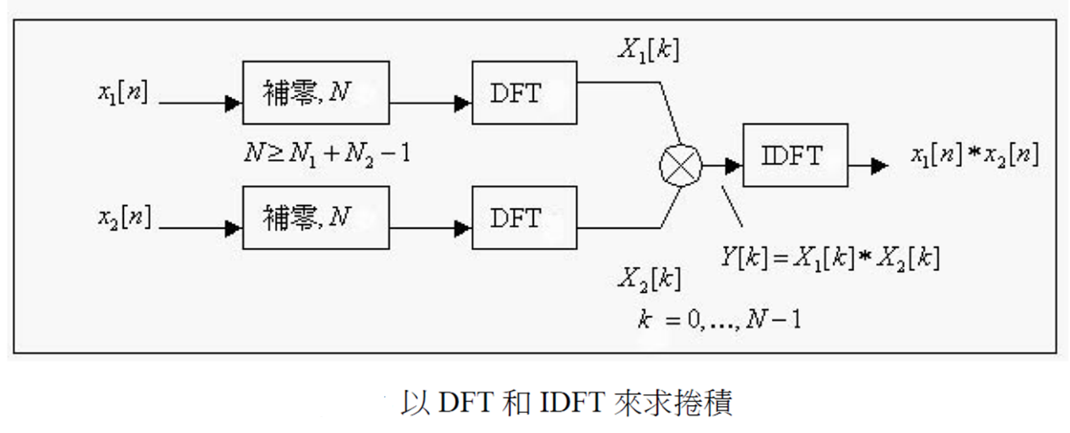

1. Overlap and add (O&A)

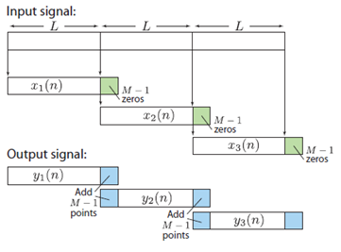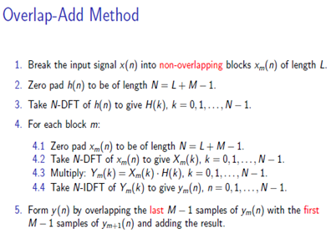

1. Overlap and save (O&S)

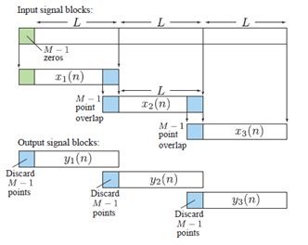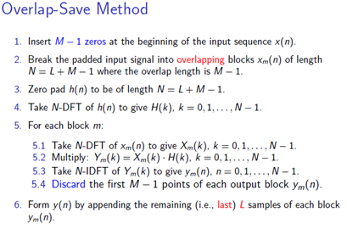

**Example :** Let x(n) = (n + 1), 0 <= n <= 9 and h(n) = {1, 0, -1}.

Implement the **overlap-save** method using N = 6 to compute y(n) = x(n)* h(n).

**solution:** Since M = 3, we will have to overlap each section with the previous one by two samples.

Now x(n) is a l0-point sequence, and we will need (M - 1) = 2 zeros

in the beginning. Since N = 6, we will need 3 sections. Let the sections be

x1(n)= {0, 0, 1,2, 3, 4}

x2(n)= {3, 4, 5, 6, 7, 8}

x3(n)= {7, 8, 9, 10, 0, 0}

Note that we have to pad x3(n) by two zeros since x(n) runs out of values at

n = 9. Now we will compute the 6-point circular convolution of each section

with h(n). (@: circular convolution)

y1 = x1(n) @ h(n) = {-3, -4, 1, 2, 2, 2}, y2 = x2(n) @ h(n) = {-4, -4, 2, 2, 2, 2}

y3 = x3(n) @ h(n) = {7, 8, 2, 2, -9, -10}

Noting that the first two samples are to be discarded, we assemble the output

y(n) as y(n)= {1, 2, 2, 2, 2, 2, 2, 2, 2, 2, -9, -10}

What is the linear convolution? Are they the same?

**Python implementation:**

1. Using the above example as a guide, we can develop a Python function to implement the

overlap-and-save and overlap-and-add methods for a very long input sequence x(n).

在程式中，必須用DFT/FFT來實現circular convolution

1. 先用上例測試你的程式
2. ，，y[n]=x[n]*h[n], 求0<n<1024. 令L=32，先以linear convolution的function直接做，再用以驗證O&A跟O&S的結果。再測試L=16及64測試O&A，評估L的大小有何影響?